- I have overall 9+ years of experience of Cloude based data management.
on Managing data platform on Azure and AWS
- Developed / Maintaining and Deployed SSIS packages for seamless ETL.
- Experience working both AWS and Azure – S3, EX2, EMR, Red-shift | Azure Blob Storage, Azure Data Factory, Azure Data-Bricks and Azure Synapse Activities.
- Designed, Developed, and Maintained scalable data pipeline, ensuring that Data is processed accurately and efficiently.
- Experience in Data Visualization using Power Bi / Dax query.
- SQL Server – Created Database, Stars schema, Snow feck, write complex query etc.
- Experience in Python, C#, shell scripting, batch file.
- Experience on Azure Data lack Storage - ADLS
- Azure - Created Storage Account, Resource Group, Subscription and Created Container and upload file.
- Created Data pipeline, Activities, Dataset, Linked Service and Triggers for scheduling job based on requirement.
- Under the Resource group – Created Blob, File, Table
- Create Serverless Database
- Created Azure Data Factory - ADF
- Created Data Pipelines
- Parameterize Activities
- Copy Activities
- Transformation – Filleter, Short, Join, Union Join, Derived Column, Sore procedure, For Each loop, If condition so and so
- Created Bricks – Spark SQL, Pyspark, Synapse, Server less SQL pool.
- Spark SQL- Created Cluster, Notebook and Table
- Created Data Frame and Container
===============================================================================

Hi, my name is Mukesh, I am an Azure Data Engineer with 9+ years of experience in database development, business intelligence and data Analytics using cloud technology.
My skill set which I am using ETL, SQL, T-SQL, Power Bi, Azure and AWS cloud technology but I am more on Azure.
I have a Handson experienced in.
- Developed / Maintaining and Deployed SSIS packages for seamless ETL.
- working both AWS and Azure – S3, EX2, EMR, Red-shift | Azure Blob Storage, Azure Data Factory (ADF), Azure Data-Bricks and Azure Synapse Activities, Azure Data lack Storage (ADLS), Azure Data Factory (ADF), Meta Data, Data set and Data Frame.
- Spark SQL, Pyspark, Synapse, Server less SQL pool.
- Data Visualization using Power Bi
- Python, C#, shell scripting, batch file.
My responsibilities were Building databases and Creating Tables, views, trigger, Index, functions and stored procedures. Writing complex query, making complex join, fine tuning, queries optimized which will not affect load on execution time. Then we had a transition from on prem to cloud services. Where my job role is minimally into ETL production support. I was mostly looking into the data sanity and the data profile in terms of checking the data curation from the source to the destination tables. Designed, Developed, and Maintained scalable data pipeline, ensuring that Data is processed accurately and efficiently.
In my resent role at CVS Health I played a pivotal role as a Azure Data Engineer, where I'll be monitoring the jobs and letting the source team to know where the source had a mismatch from the source end or in case if there are any minimal transformations to be done, we would be taking care as a tickets from the production support and we would be working on them.
Infosys :Development into Azure where I would be connecting to the different third party sources to get in the data in house, and that's where we had the transformations implemented. Responsible for creating Linked services, datasets, pipelines in Azure data factory. Developed pipelines using copy activity, lookup activity, Metadata activity to fetch data from different sources and loaded it into Azure synapse analytics. Extensively involved in writing transforming data in PySpark and pushing into ADLS. Implemented Incremental load strategy for loading on daily basis. Worked on Azure Devops to deploy Code. Once everything is completed, we will be raising PR and my TL approves the PR by doing Unit Testing.
- CSV Health, New Jesey – May 2023 to till Date.
- Infosys – Everest Reinsurance, New Jesey – Oct 2022 to May 2023
- RSI – IRS – Road Island – Oct 2019 to Sept 2022
- Fannie Mae, New York – Jan 2017 to Oct 2019
- Kapp Soft PVT, LTD, Chennai, India – Feb 2017 to Dec 2015

I am responsible for designing, implementing, and managing data solutions on the Azure platform. Here are some common use cases and examples of tasks performed by Azure Data Engineers:
- Data Ingestion and Integration: I need to ingest data from various sources such as databases, files, APIs, and streaming platforms into Azure. I use Azure Data Factory to orchestrate the extraction, transformation, and loading (ETL) of data from an on-premises SQL Server database to Azure Blob Storage.
- Data Transformation and Processing: I worked on data transformation and processing tasks to prepare the data for analysis and reporting. Azure Databricks and Azure Synapse Analytics I used for large-scale data transformations using tools like Apache Spark.
- Data Storage and Management: Azure provides various data storage options, and as a Data Engineer, I will need to select and manage the appropriate storage solutions for your data. For instance, you could use Azure SQL Database or Azure Cosmos DB for structured data, Azure Data Lake Storage for big data and unstructured data, or Azure Blob Storage for file storage.
- Data Warehousing: Implementing data warehousing solutions is a common use case for Azure Data Engineers. Azure Synapse Analytics (formerly Azure SQL Data Warehouse) offers scalable and distributed analytics capabilities for handling large datasets.
- Data Modeling and Analysis: Data Engineers may collaborate with data scientists and analysts to design and implement data models for analytical workloads. Azure Analysis Services or Azure Databricks can be used for building and deploying models to support interactive data analysis.
- Real-time Data Processing: Azure Stream Analytics is a platform that enables real-time processing of streaming data from sources like IoT devices, social media feeds, or log files. As a Data Engineer, you may configure and optimize streaming pipelines to extract insights from live data streams.
- Data Governance and Security: Azure Data Engineers play a crucial role in ensuring data governance and security practices are implemented. They set up data access controls, implement encryption, monitor data quality, and establish data retention policies.
- DevOps and Automation: Automating data pipelines, monitoring data processes, and managing deployments are important tasks for Azure Data Engineers. They may use tools like Azure DevOps, Azure Monitor, and Azure Automation to achieve continuous integration and delivery.
=================================================================================

Responsibilities
- Assure that data is cleansed, mapped, transformed, and otherwise optimised for storage and use according to business and technical requirements
- Develop and maintain innovative Azure solutions
- Solution design using Microsoft Azure services and other tools
- The ability to automate tasks and deploy production standard code (with unit testing, continuous integration, versioning etc.)
- Load transformed data into storage and reporting structures in destinations including data warehouse, high speed indexes, real-time reporting systems and analytics applications
- Build data pipelines to collectively bring together data
- Other responsibilities include extracting data, troubleshooting and maintaining the data warehouse
- Key Responsibilities of an Azure Data Engineer
- • Designing and implementing scalable and secure data processing pipelines using Azure Data Factory, Azure Databricks, and other Azure services.
- • Managing and optimizing data storage using Azure Data Lake Storage, Azure SQL Data Warehouse, and Azure Cosmos DB.
- • Developing data models and maintaining data architecture to support data analytics and business intelligence reporting.
- • Ensuring data quality and consistency through data cleaning, transformation, and integration processes.
- • Monitoring and troubleshooting data-related issues within the Azure environment to maintain high availability and performance.
- • Collaborating with data scientists, business analysts, and other stakeholders to understand data requirements and implement appropriate data solutions.
- • Implementing data security measures, including encryption, access controls, and auditing, to protect sensitive information.
- • Automating data pipelines and workflows to streamline data ingestion, processing, and distribution tasks.
- • Utilizing Azure's analytics services, such as Azure Synapse Analytics, to provide insights and support data-driven decision-making.
- • Keeping abreast of the latest Azure features and technologies to enhance data engineering processes and capabilities.
- • Documenting data procedures, systems, and architectures to maintain clarity and ensure compliance with regulatory standards.
- • Providing guidance and support for data governance, including metadata management, data lineage, and data cataloging.

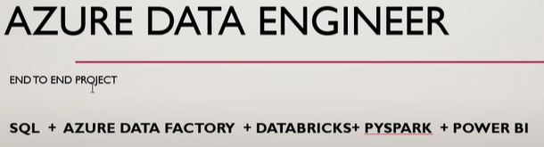
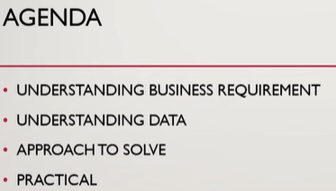
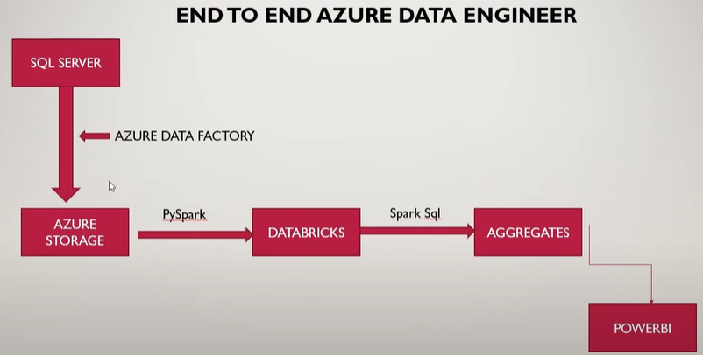
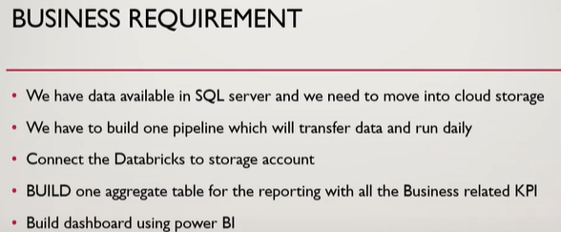

Create Azure Storage account.
Create container – Store data SQL to Container
Create data factory – create data pipeline (Copy Activity, Configurated Source and Sink -Create Linked service), This data pipeline bring data from SQL and load into the container. After configuration completed, we can check data it is using Debug and data looks good then publish and then the schedule job using trigger or Manually run data pipeline for clicking on Trigger button and go to on Monitor Monitor data pipeline or job. After that we will connect with databricks.
Create Databricks:
Create data bricks- go to compute and create cluster after that will mount data bricks to our blog storage. For mount data bricks to blog storage we need create notebook in this notebook we can select Payton or SQL, select python write blow code:
Read CSV file
Show data: Display(df)
Create tempview:
Now you can run any SQL query
%sql
Select * from pizaa_sales_analysis
Create aggregate Table:
Only some column I want to add in my aggregate table

